**Sports Center Management System – Software Design Document**

1. **Revision History**

|  |  |  |  |
| --- | --- | --- | --- |
| *Version* | *Date* | *Author* | *Change Description* |
| 1.0 | 26/04/2018 | Ali Şahin Balıkçı |  |

1. **Introduction**

*2.1 Purpose and Scope*

This document’s purpose is the explain details of software design. General views and behaviors of the system explicitly explained. Interactions between interfaces and other components of the system will be explained. Also, design constraints will be explained.

*2.2 Document Overview*

In design constraints part of this document, hardware and development constraints will be explained. General descriptions and the impacts of the all limitations will be described.

In design details part of this document, architecture of the software will be explicitly described. Entity-Relations, interfaces, views, controllers and models of the system, interactions between them and other components of the system will be specifically revealed.

*2.3 System Overview*

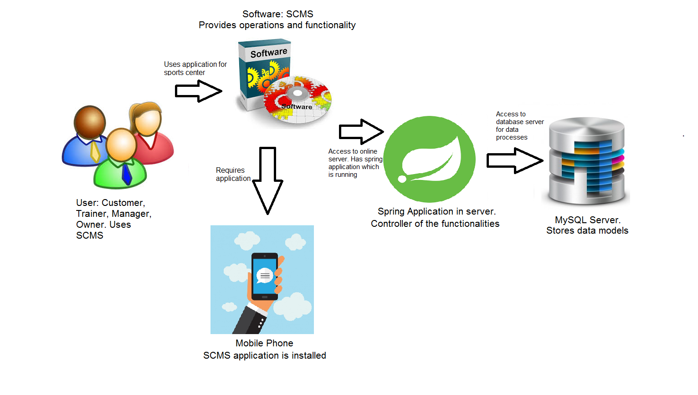

*2.4 Definitions Acronyms, and Abbreviations*

|  |  |
| --- | --- |
| *Term/Acronym* | *Definition* |
| SRS | System Requirements Specifications |
| SDD | Software Design Description |
| SQL | Structured Query Language |
| JVM | Java Virtual Machine |
| SCMS | Sports Center Management System |

1. **Design Constraints and Decisions**

* The system should be developed in accordance with Object Oriented Design. OO design is important for future development and it is more useful for teams.
* The system’s official language is Java. In mobile application, we should use Java for Android. Java has great support in server side and it required for Android mobile application development.
* Model-View- Controller is the system’s architectural pattern. In this way, we can separate critical system parts easily. It decreases cost of maintenance.
* The system’s database management system is MySQL. Because it is open source and we can easily learn how to use it.
* In mobile side, the application supports 4.2 or newer versions of Android. It provides wide support for maximum users.
* The Server is available for every time. So, we need to use cloud servers. In this case, we rent a server from Digital Ocean.
* In front end development, we use bootstrap 4 for better and modern view.
* The development environments; Android Studio for Mobile application, and Sts tool for back-end development. It is important for team works. Because it decreases inconsistency.
* Security of user logins will be provided by AES-256 (Advanced Encryption System).

1. **Design Details**

*4.1 Software Components*

Please check SSD – Appendix A for to see class diagram.

*4.2 Software Behavior*

Please check SSD – Appendix B for to see sequence diagrams.

State Diagram of “Course” Class:

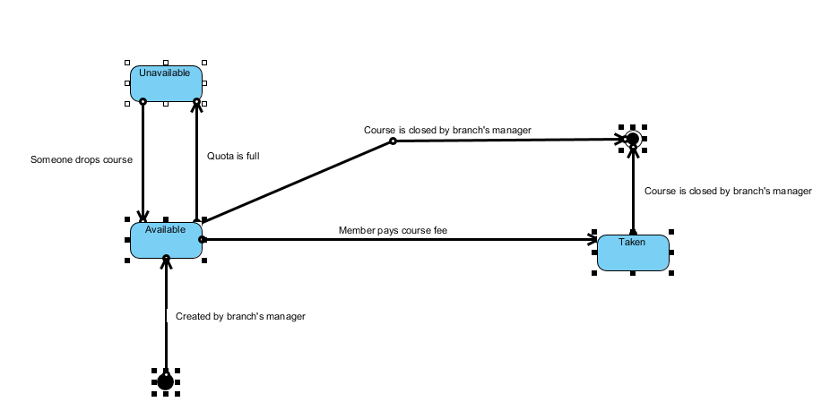

*4.3 Data Model (E-R Diagram)*

Please check SSD – Appendix C for to see E-R diagram.

*4.4 User Interface Design*

Please check SSD – Appendix E for to see interfaces.

*4.5 Dialog Screen Design*

Please Check SSD – Appendix F for to see dialog screens.

1. **Requirements Traceability**

Please check SSD – Appendix D for to see traceability matrix.

1. **Appendices**

* SDD – Appendix A – Class Diagram
* SDD – Appendix B – Sequence Diagrams
* SDD – Appendix C – E-R Diagram
* SDD – Appendix D – Traceability Matrix
* SSD – Appendix E – Interfaces
* SSD – Appendix F – Dialog Screens